**VISVESVARAYA TECHNOLOGICAL UNIVERSITY, BELAGAVI**



**REPORT ON DBMS MINI PROJECT(21CSL55)**

**“LIBRARY MANAGEMENT SYSTEM”**

Submitted in partial fulfillment for the award of Degree of,

**BACHELOR OF ENGINEERING**

**IN**

**COMPUTER SCIENCE &ENGINEERING**

**By**

|  |  |
| --- | --- |
| **Student Name : Nikita Patil** | **USN:2BU21CS075** |
| **Student Name : Pranjal B.** | **USN:2BU21CS086** |
|  |  |
|  |  |

**Under the Guidance of**

**Dr. S.F. Rodd/ Mrs.S.A.Kokatanoor**

**Prof./ Asst.Prof. CSE Dept**



**DEPARTMENT OF COMPUTER SCIENCE & ENGINEERING**

**Accredited by NBA**

**S.S EDUCATION TRUST**

**S. G. BALEKUNDRI INSTITUTE OF TECHNOLOGY**



**2023– 2024**

**S. G. BALEKUNDRI INSTITUTE OF TECHNOLOGY**

**Shivabasavanagar, Belagavi-10, Karnataka.**



**DEPARTMENT OF COMPUTER SCIENCE & ENGINEERING**

**Accredited by NBA**

**CERTIFICATE**

This is to certify that the DBMS mini project entitled **“Library Management System”** has been successfully completed by

|  |  |
| --- | --- |
| **STUDENT NAME : Nikita Patil** | **USN:2BU21CS075** |
| **STUDENT NAME : Pranjal B** | **USN:2BU21CS086** |
|  |  |
|  |  |

the bonafide students of **DEPARTMENT OF COMPUTER SCIENCE & ENGINEERING,**

**S.G. BALEKUNDRI INSTITUTE OF TECHNOLOGY** of the **VISVESVARAYA TECHNOLOGICAL UNIVERSITY, BELAGAVI** during the year 2023–2024. It is certified that all corrections/suggestions indicated for Internal Assessment have been incorporated in the report deposited in the departmental library. The Project Work (21CSL55) has been approved as it satisfies the academic requirements in respect of DBMS mini Project work prescribed for the Bachelor of Engineering Degree.

**Dr. S.F. Rodd /**

**Mrs.S.A.Kokatanoor Dr. B. S. Halakarnimath Dr.B. R. Patagundi**

**Project Guide Head of the Department Principal**

**TABLE OF CONTENTS**

**Ch.no Description Pg.no**

Acknowledgement…………………………………………………………...…...i

Abstract…………………………………………………………………………..ii

List of figures…………………………………………………………………… iii

List of tables…………………………………………………………………… ..iv

1. **INTRODUCTION** 1
   1. Problem statement 1
   2. Objectives 1
   3. SQL commands 2
2. **METHODOLOGIES** 3
   1. About backend connection 3
   2. Introduction to server 4
3. **SYSTEM REQUIREMENTS AND SPECIFICATIONS** 5
   1. Software requirements 5
   2. Hardware requirements 5

1. **SYSTEM DESIGN**  6
   1. ER Diagram 6
   2. Schema Diagram 7
2. **IMPLEMENTATION**  8
   1. Technologies used 8
   2. Database creation 9
   3. Implementation codes 12
3. **RESULTS** 15
   1. Home page 15
   2. User login page 15
   3. User signup page 15
   4. Admin login page 16

* 1. User dashboard page 16
  2. Issued book page 16

* 1. User change password page 17
  2. My profile page 17

* 1. Admin dashboard page 17
  2. Add category page 18

* 1. Manage category page 18

6.12 Add author page 18

* 1. Manage author page 19
  2. Add book page 19
  3. Manage book page 19
  4. Issue new book page 20
  5. Manage issued book page 20
  6. Manage reg students page 20

**REFERENCES** 21

**ACKNOWLEDGEMENT**

The satisfaction and euphoria that accompany a successful completion of any task would be incomplete without the mention of people who made it possible, success is the epitome of hard work and perseverance, but steadfast of all is encouraging guidance.

So, with gratitude we acknowledge all those whose guidance and encouragement served as beacon of light and crowned the effort with success.

We thank our project guide **Dr.S F Rodd** ,Professor in Department of Computer Science & Engineering, who has been our source of inspiration. He has been especially enthusiastic in giving his valuable guidance and critical reviews.

The selection of this project work as well as the timely completion is mainly due to the interest and persuasion of my project coordinator **Mrs. Sheetal Kokatanoor,** Assistant Professor, Department of Computer Science & Engineering. We will remember her contribution for ever.

We sincerely thank, **Dr. B. S. Halakarnimath**, Professor and Head, Department of Computer Science & Engineering who has been the constant driving force behind the completion of the project.

We thank Principal **Dr. B. R. Patagundi,** for his constant help and support throughout.

We are also indebted to **Management of S. G. Balekundri Institute of Technology, Belagavi** for providing an environment which helped us in completing the project.

Also, we thank all the teaching and non-teaching staff of Department of Computer Science & Engineering for the help rendered.

Finally, we would like to thank my parents and friends whose encouragement and support was invaluable.

|  |  |
| --- | --- |
| STUDENT NAME: Nikita Patil | USN: 2BU21CS075 |
| STUDENT NAME: Pranjal B. | USN: 2BU21CS086 |
|  |  |
|  |  |

**ABSTRACT**

The "Student Library Management System" is a comprehensive software solution designed to streamline and automate the management of library resources in educational institutions. This project aims to provide an efficient platform for librarians and students to manage library operations effectively. The system encompasses various modules to handle tasks such as book management, student registration, book issuance, returns, and administrative functions.

Key features of the system include:

Student Registration: Enables the registration of students into the library system, capturing essential details such as student ID, full name, contact information, and login credentials.

Book Management: Facilitates the management of books available in the library, including adding new books, updating existing book information, and categorizing books based on genres or subjects.

Book Search and Availability: Provides a search interface for students to find books based on title, author, category, or ISBN number. The system also displays real-time availability status to inform students about the availability of desired books.

Book Issuance and Returns: Allows students to borrow books from the library by scanning their student ID or entering their credentials. The system records issuance details such as book ID, student ID, issuance date, and expected return date. Additionally, it manages the return process and calculates fines for overdue books.

Admin Dashboard: Offers an administrative dashboard for librarians and administrators to monitor library activities, view statistics, generate reports, and perform configuration tasks.

Notifications and Reminders: Sends automated notifications and reminders to students regarding upcoming due dates, overdue books, and other relevant announcements.

Security and Access Control: Implements robust security measures to safeguard sensitive data and restrict unauthorized access to the system functionalities.

The "Student Library Management System" enhances the efficiency of library operations, improves access to educational resources for students, and provides valuable insights for administrators to optimize resource allocation and decision-making. This project report explores the system architecture, design methodologies, implementation details, user documentation, and future enhancements to support continuous improvement and scalability of the system.

**LIST OF FIGURES**

Figure 1.1 Configuration code snippet 3

Figure 1.2 ER Diagram 6

Figure 1.3 Schema Diagram 7

Figure 1.4 Table admin 9

Figure 1.5 Table books 9

Figure 1.6 Table authors 10

Figure 1.7 Table category 10

Figure 1.8 Table issued_book_details 11

Figure 1.9 Table student 11

Figure 1.10 Home page 15

Figure 1.11 User login page 15

Figure 1.12 User signup page 15

Figure 1.13 Admin login page 16

Figure 1.14 User dashboard page 16

Figure 1.15 Issued book page 16

Figure 1.16 User change password page 17

Figure 1.17 My profile page 17

Figure 1.18 Admin dashboard page 17

Figure 1.19 Add category page 18

Figure 1.20 Manage category page 18

Figure 1.21 Add author page 18

Figure 1.22 Manage author page 19

Figure 1.23 Add book page 19

Figure 1.24 Manage book page 19

Figure 1.25 Issue new book page 20

Figure 1.26 Manage issued book page 20

Figure 1.27 Manage reg students page 20

**LIST OF TABLES**

Table 1.1 SQL commands 10

Table 1.2 ER relationships 14

**CHAPTER 1**

**INTRODUCTION**

* 1. **PROBLEM STATEMENT**

In the physical library management system, manual processes, outdated technology, and disjointed systems lead to inefficiencies and errors. Our project aims to develop a modern library management system to automate processes, integrate systems, and enhance user experience. By automating cataloging and record-keeping, integrating systems, and implementing online access, we streamline operations, ensure data consistency, and improve accessibility. Real-time reporting and analytics capabilities empower administrators with insights for informed decision-making. Through this project, we address these challenges, transforming the library management system into a modern, efficient, and user-friendly platform.

**1.2 OBJECTIVES:**

* **Automate processes**: Develop automated cataloging and record-keeping systems to reduce manual errors and administrative workload.
* **Integrate systems**: Consolidate disparate systems into a unified platform to ensure data consistency and streamline administrative tasks.
* **Enhance user experience**: Implement online access and self-service functionalities to improve accessibility and convenience for users.
* **Enable real-time reporting**: Introduce reporting and analytics capabilities to provide administrators with insights for informed decision-making.
* **Modernize library management**: Transform the physical library management system into a modern, efficient, and user-centric platform to meet the evolving needs of librarians and users.
* **Ensure scalability and adaptability**: Design the system to be scalable and adaptable to accommodate future growth, technological advancements, and evolving user needs, ensuring its long-term effectiveness and relevance in the ever-changing library landscape.

**1.3 SQL COMMANDS:**

| SQL Command | Use | Example |
| --- | --- | --- |
| SELECT | Retrieve data from one or more tables | SELECT * FROM tblbooks;<br> SELECT BookName, BookPrice FROM tblbooks WHERE CatId = 5; |
| INSERT | Insert new records into a table | INSERT INTO tblstudents (StudentId, FullName, EmailId) VALUES ('SID013', 'John Smith', 'john@example.com'); |
| UPDATE | Update existing records in a table | UPDATE tblbooks SET BookPrice = 25.00 WHERE id = 1; |
| DELETE | Delete records from a table | DELETE FROM tblauthors WHERE id = 3; |
| JOIN | Combine rows from two or more tables based on a related column | SELECT b.BookName, s.FullName FROM tblissuedbookdetails ibd JOIN tblbooks b ON ibd.BookId = b.id JOIN tblstudents s ON ibd.StudentID = s.StudentId; |
| GROUP BY | Group rows that have the same values into summary rows | SELECT c.CategoryName, COUNT(*) AS TotalBooks FROM tblbooks b JOIN tblcategory c ON b.CatId = c.id GROUP BY c.CategoryName; |
| ORDER BY | Sort the result set in ascending or descending order | SELECT * FROM tblbooks ORDER BY BookName ASC; |
| WHERE | Filter records based on specified conditions | SELECT * FROM tblbooks WHERE CatId = 5; |
| LIMIT | Limit the number of records returned | SELECT * FROM tblbooks LIMIT 5; |

**Table 1.1 SQL commands**

**CHAPTER 2**

**METHODOLOGY**

**2.1 ABOUT BACKEND CONNECTION:**

**Database Layer:** This layer consists of the database management system (DBMS) where all data related to the library management system is stored. In this project, the DBMS used is MySQL, indicated by the SQL commands and structure defined for tables such as `tblbooks`, `tblstudents`, etc.

**Application Layer:** The application layer contains the business logic and application code responsible for processing user requests, interacting with the database, and generating responses. This layer can be implemented using various programming languages and frameworks. We have used PHP for server-side scripting.

**Connection Setup:**

The connection setup involves configuring the backend to establish a connection with the database management system. This typically includes:

* Database Configuration**:** Setting up the database server, creating the necessary databases and tables, and configuring user permissions and access rights.
* Backend Configuration**:** Configuring the backend application to connect to the database. This involves specifying the database host, port, username, password, and other connection parameters. In PHP applications, this is often done using functions like `mysqli_connect()` or PDO (PHP Data Objects) to establish a connection to the MySQL database.

This is the configuration code used in our project for backend connection:

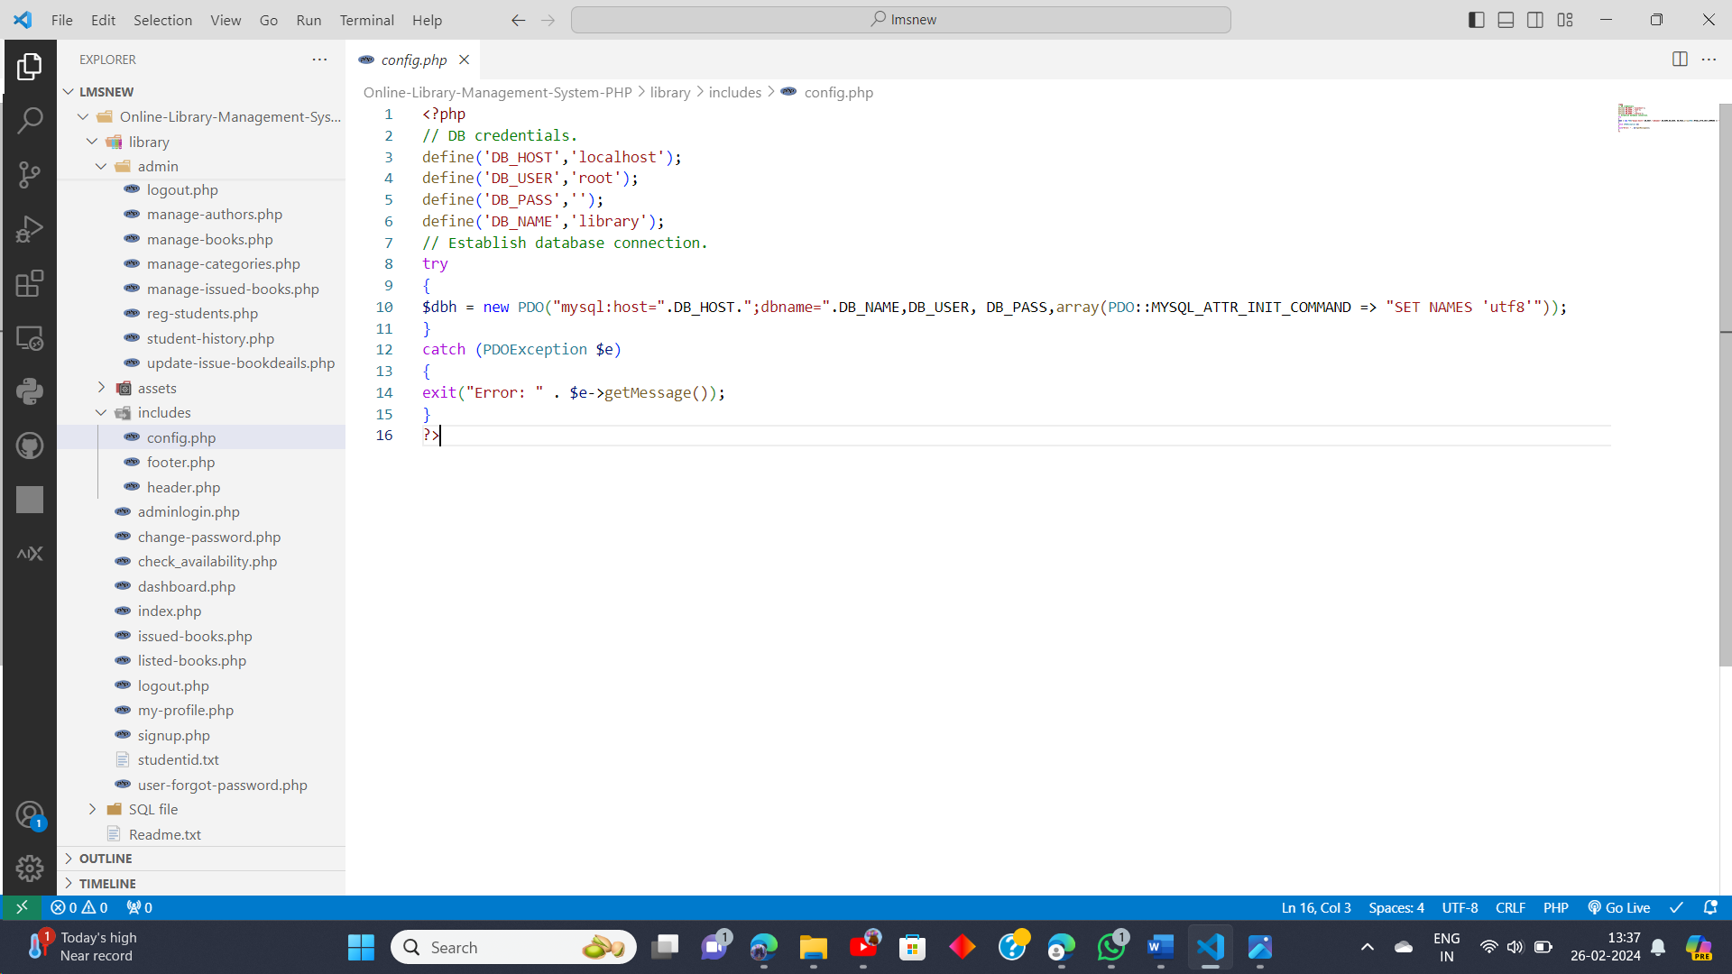

**Figure 1.1 Configuration code snippet**

* DB credentials: These constants (`DB_HOST`, `DB_USER`, `DB_PASS`, `DB_NAME`) store the database connection details, including the host (localhost), username (root), password (blank in this case), and database name (library).
* Establish database connection: The `try-catch` block attempts to establish a connection to the MySQL database using PDO. The `PDO()` constructor is used to create a new PDO object, passing the database DSN (Data Source Name) as the first argument, which includes the host, database name, username, and password.
* Error handling: If an exception (PDOException) occurs during the connection attempt, the `catch` block captures the exception, and an error message is displayed, providing details about the error.

This code snippet demonstrates the backend connection setup in a PHP application, where the application connects to the MySQL database using PDO. It's a common approach to establishing database connections in PHP applications, ensuring secure and reliable communication between the application and the database management system.

**2.2 INTRODUCTION TO SERVER:**

To host a library management system, you need a server configured with the following components:

* Operating System: Choose a stable and secure operating system like Linux (e.g., Ubuntu, CentOS) or Windows Server.
* Web Server: Install and configure a web server such as Apache or Nginx to handle HTTP requests.
* Database Server: Set up a database management system (e.g., MySQL, PostgreSQL) to store and manage library data.
* Server-Side Scripting: Use a server-side scripting language like PHP, Python, or Node.js to build the backend logic of the system.
* Backup and Monitoring: Set up regular backups of data and monitor server performance to ensure reliability and availability.

**CHAPTER 3**

**SYSTEM REQUIREMENTS AND SPECIFICATIONS**

**3.1 SOFTWARE REQUIREMENTS:**

1. Web Server:

Apache HTTP Server: To serve web pages locally during development.

XAMPP: Bundled package including Apache, MySQL, PHP, and phpMyAdmin for local

development environment setup.

1. Database Management System:

MySQL: Database system for storing and managing library data.

1. Development Tools:

Visual Studio Code (VSCode): Integrated Development Environment (IDE) for writing and

editing code.

Browser: Google Chrome for testing and debugging web pages.

**3.1 HARDWARE REQUIREMENTS:**

**Server Hardware (for Deployment):**

Processor: Dual-core or higher for handling server operations efficiently.

RAM: At least 4GB, though 8GB or more would be beneficial for smoother performance.

Storage: 512 SSD storage for faster read/write operations.

Network: Stable internet connection for serving requests to client devices.

**CHAPTER 4**

**SYSTEM DESIGN**

**4.1 ER DIAGRAM**

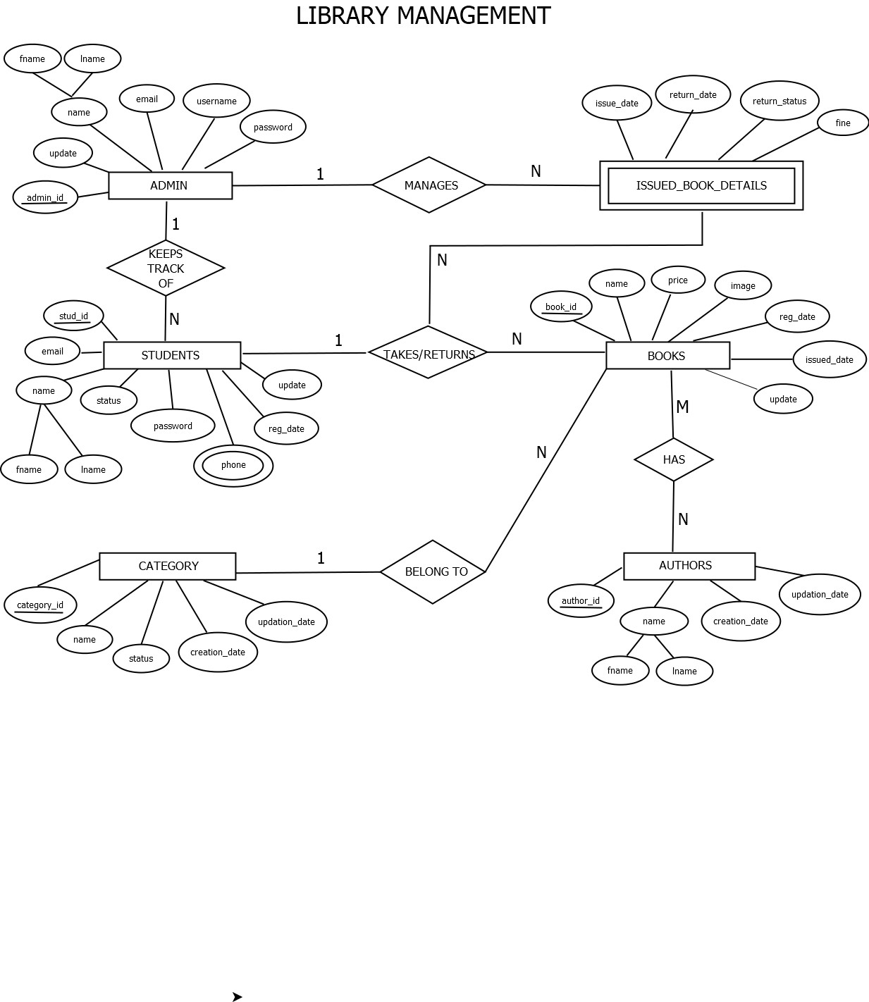

**Figure 1.2 ER Diagram**

**Relationships and Cardinality ratios:**

| **Entity 1** | **Relationship** | **Entity 2** | **Cardinality Ratio** |
| --- | --- | --- | --- |
| Admin | Manages | Books | 1: M |
| Admin | Manages | IssuedBookDetails | 1: M |
| Admin | Keepstrackof | Students | 1: M |
| Students | Take/Return | Books | 1: M |
| Books | BelongsTo | Category | M :1 |
| Books | Have | Authors | M: N |

**Table 1.2 ER Relationships**

**4.2 SCHEMA DIAGRAM:**

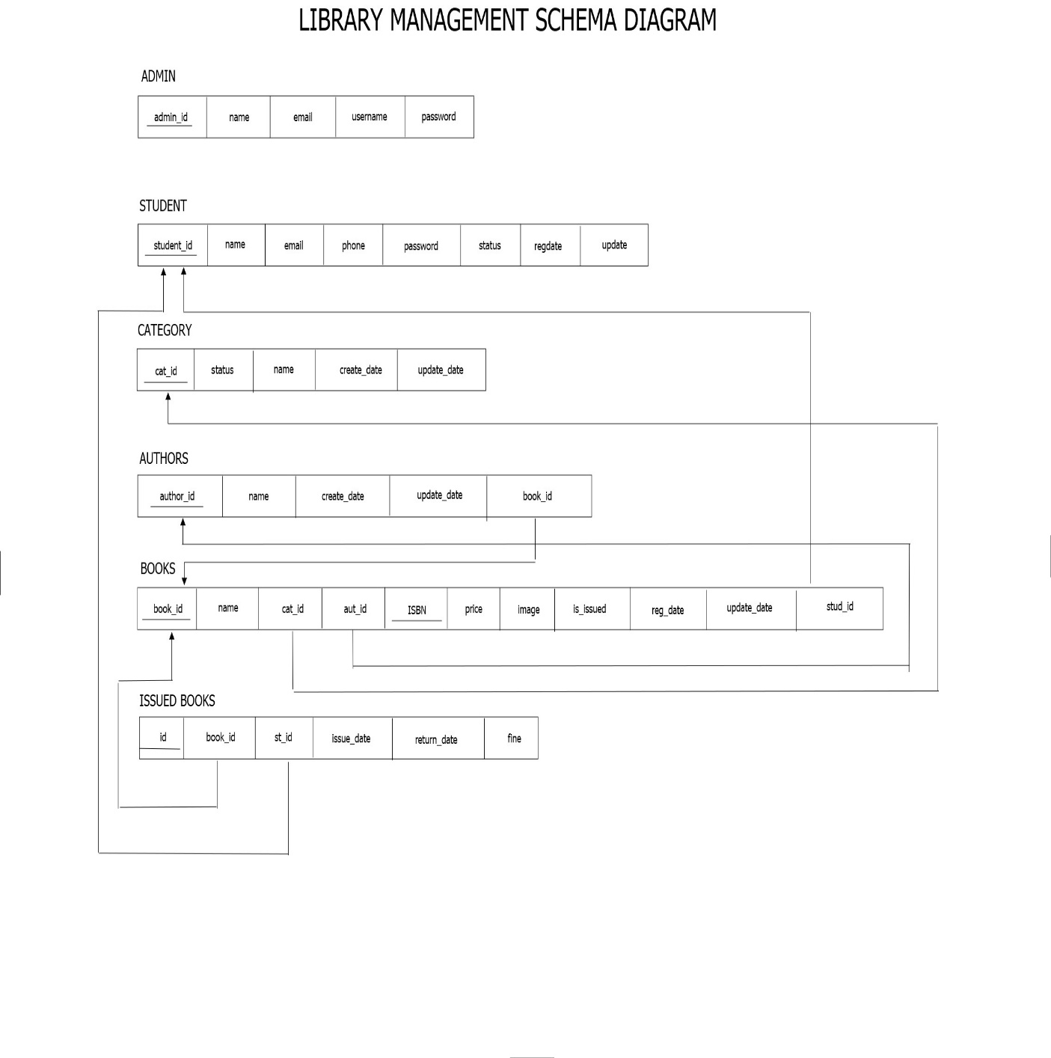

**Figure 1.3 Schema Diagram**

* **Admin:-** Primary Key: id
* **Books:-** Primary Key: id

Foreign Key: Admin_id (refers to Admin's id)

Foreign Key: Category_id (refers to Category's id)

* **IssuedBookDetails:-** Primary Key: id

Foreign Key: BookId (refers to Books' id)

Foreign Key: StudentID (refers to Students' id)

* **Students:-** Primary Key: id
* **Category:-** Primary Key: id
* **Authors:-** Primary Key: id

**CHAPTER 5**

**IMPLEMENTATION**

**5.1 TECHNOLOGIES USED:**

**Development Environment**

* The Library Management System was developed using a combination of software tools and technologies.
* The primary development environment consisted of:
  + Visual Studio Code (VSCode) as the Integrated Development Environment (IDE).
  + XAMPP for providing a local server environment including Apache, MySQL, and PHP.
  + MySQL Workbench for database design and management.

**Database Design**

* The database schema was designed to capture all relevant information for managing the library system effectively.
* Detailed discussions on the tables, columns, relationships, and constraints were carried out to ensure data integrity and efficiency.
* Normalization techniques were applied to reduce redundancy and improve data organization.

**Backend Development**

* Backend logic was implemented using PHP scripting language to handle database interactions and business logic.
* PHP scripts were responsible for querying the database, processing user requests, and generating dynamic content for the frontend.
* Object-oriented programming (OOP) principles were employed to modularize code and improve maintainability.

**Frontend Development**

* The user interface was developed using HTML, CSS, and JavaScript.
* Responsive design principles were applied to ensure compatibility across different devices and screen sizes.
* Bootstrap framework was utilized to streamline the frontend development process and enhance UI consistency.

**5.2 DATABASE CREATION:**

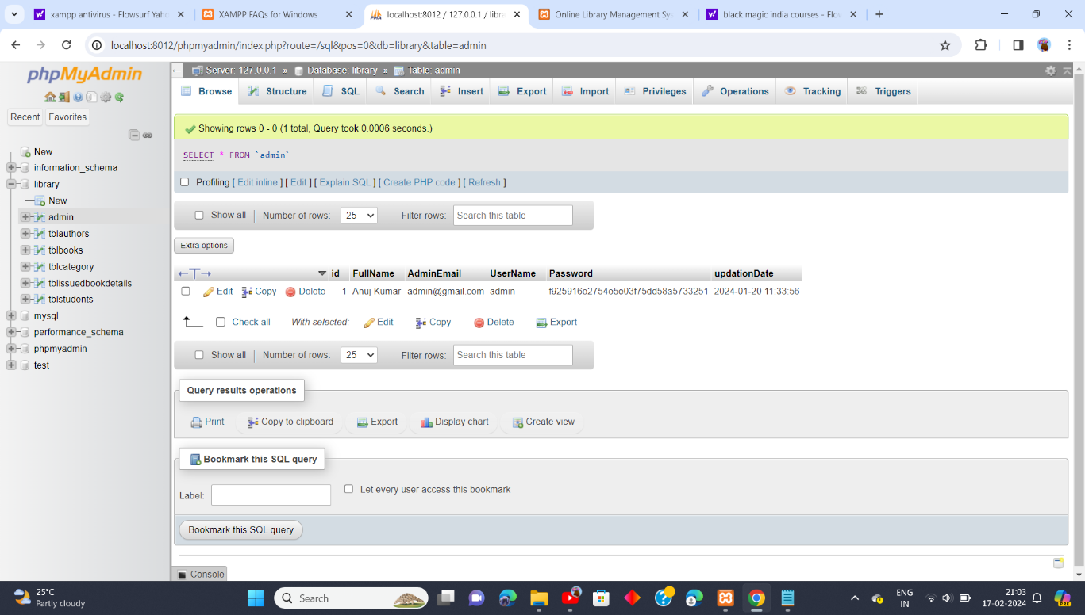

**Figure 1.4 Table admin**

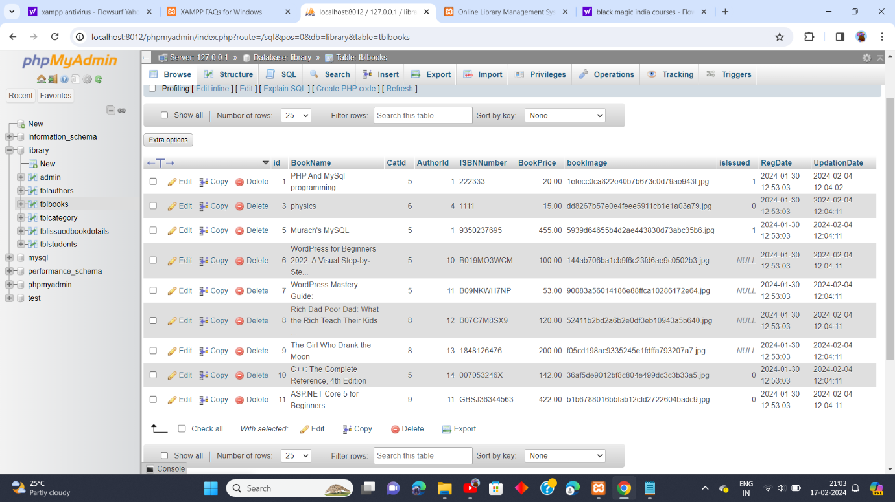

**Figure 1.5 Table books**

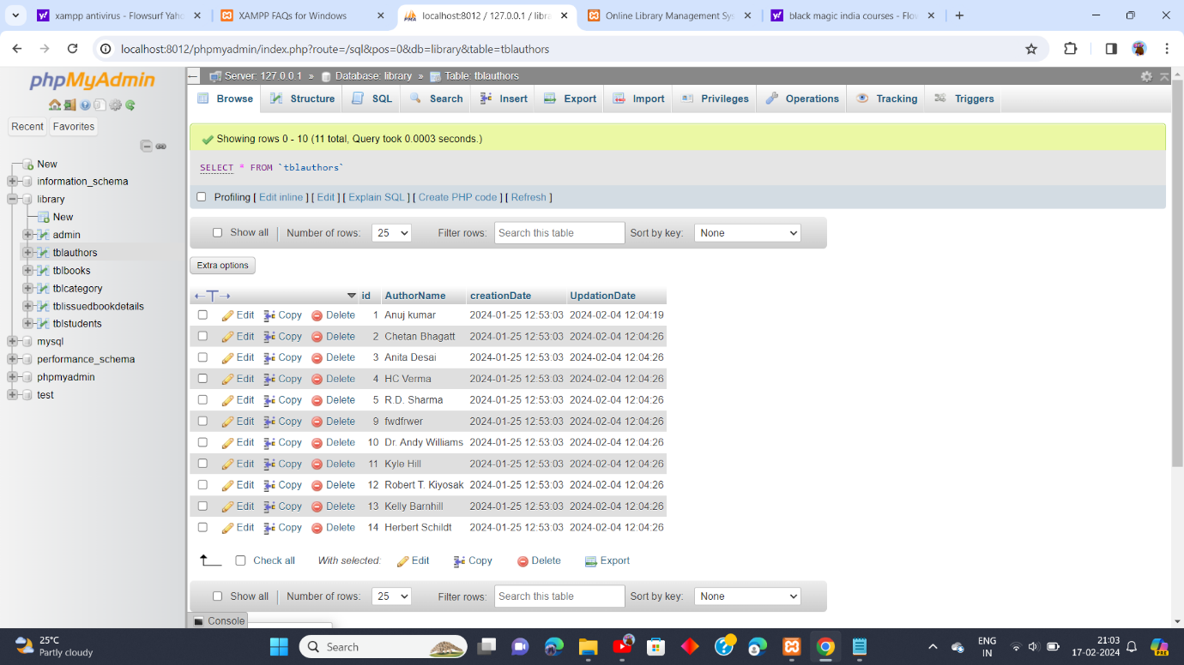

**Figure 1.6 Table authors**

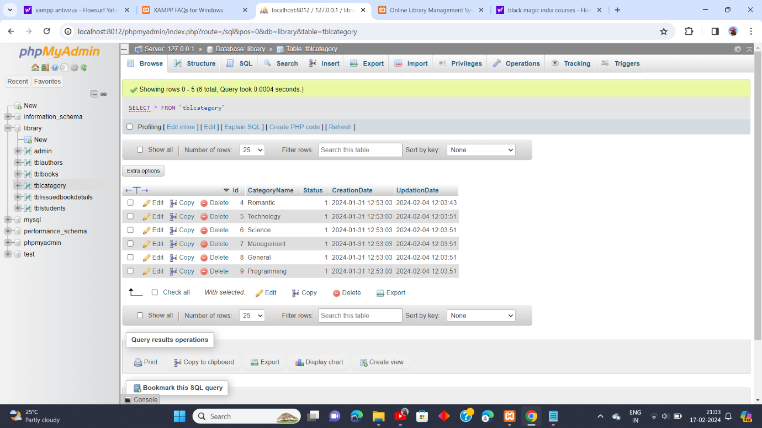

**Figure 1.7 Table category**

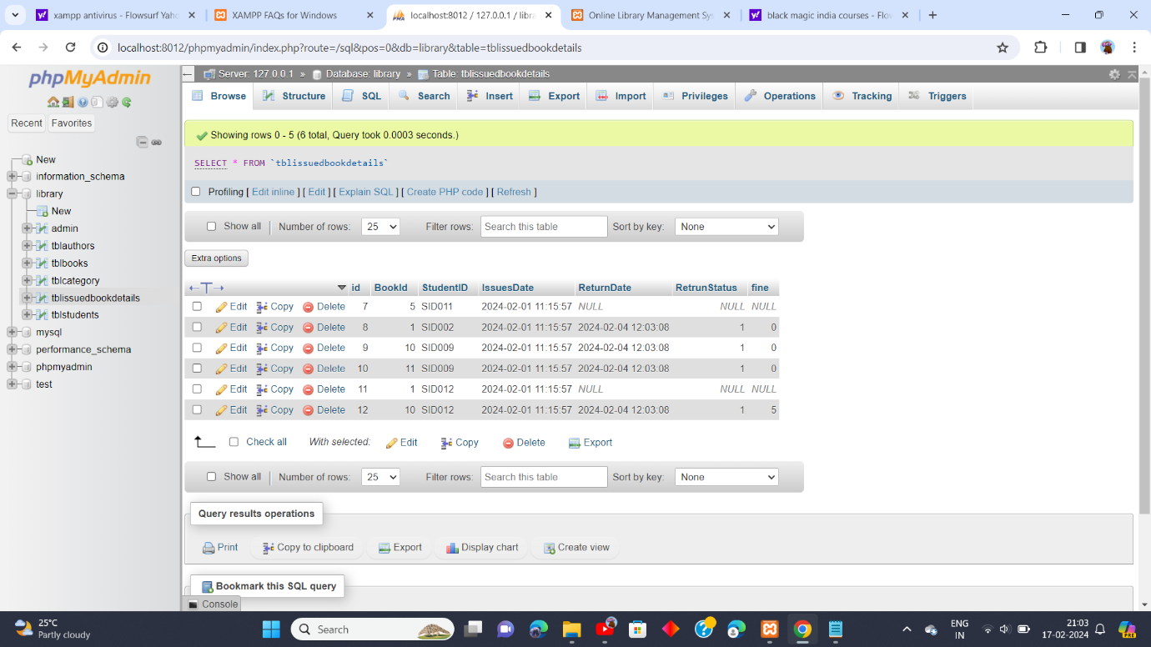

**Figure 1.8 Table issued_book_details**

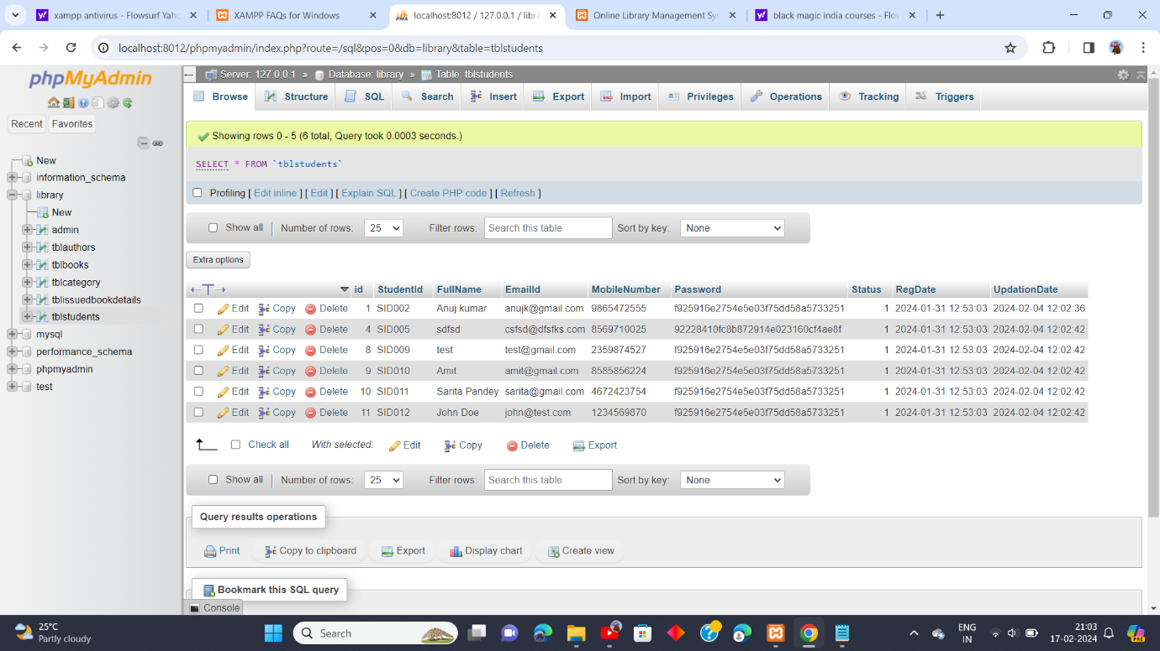

**Figure1.9 Table students**

**5.3 IMPLEMENTATION CODE (INDEX.PHP)**

<?php

session_start();

error_reporting(0);

include('includes/config.php');

if($_SESSION['login']!=''){

$_SESSION['login']='';

}

if(isset($_POST['login']))

{

$email=$_POST['emailid'];

$password=md5($_POST['password']);

$sql ="SELECT EmailId,Password,StudentId,Status FROM tblstudents WHERE EmailId=:email and Password=:password";

$query= $dbh -> prepare($sql);

$query-> bindParam(':email', $email, PDO::PARAM_STR);

$query-> bindParam(':password', $password, PDO::PARAM_STR);

$query-> execute();

$results=$query->fetchAll(PDO::FETCH_OBJ);

if($query->rowCount() > 0)

{

 foreach ($results as $result) {

 $_SESSION['stdid']=$result->StudentId;

if($result->Status==1)

{

$_SESSION['login']=$_POST['emailid'];

echo "<script type='text/javascript'> document.location ='dashboard.php'; </script>";

} else {

echo "<script>alert('Your Account Has been blocked .Please contact admin');</script>";

}

}

}

else{

echo "<script>alert('Invalid Details');</script>";

}

}

?>

<!DOCTYPE html>

<html xmlns="http://www.w3.org/1999/xhtml">

<head>

    <meta charset="utf-8" />

    <meta name="viewport" content="width=device-width, initial-scale=1, maximum-scale=1" />

    <meta name="description" content="" />

    <meta name="author" content="" />

    <title>Online Library Management System | </title>

    <!-- BOOTSTRAP CORE STYLE  -->

    <link href="assets/css/bootstrap.css" rel="stylesheet" />

    <!-- FONT AWESOME STYLE  -->

    <link href="assets/css/font-awesome.css" rel="stylesheet" />

    <!-- CUSTOM STYLE  -->

    <link href="assets/css/style.css" rel="stylesheet" />

    <!-- GOOGLE FONT -->

    <link href='http://fonts.googleapis.com/css?family=Open+Sans' rel='stylesheet' type='text/css' />

</head>

<body>

    <!------MENU SECTION START-->

<?php include('includes/header.php');?>

<!-- MENU SECTION END-->

<div class="content-wrapper">

<div class="container">

<!--Slider---->

     <div class="row">

              <div class="col-md-10 col-sm-8 col-xs-12 col-md-offset-1">

                    <div id="carousel-example" class="carousel slide slide-bdr" data-ride="carousel" >

                    <div class="carousel-inner">

                        <div class="item active">

                            <img src="assets/img/1.jpg" alt="" />

                        </div>

                        <div class="item">

                            <img src="assets/img/2.jpg" alt="" />

                        </div>

                        <div class="item">

                            <img src="assets/img/3.jpg" alt="" />

                        </div>

                    </div>

                    <!--INDICATORS-->

                     <ol class="carousel-indicators">

                        <li data-target="#carousel-example" data-slide-to="0" class="active"></li>

                        <li data-target="#carousel-example" data-slide-to="1"></li>

                        <li data-target="#carousel-example" data-slide-to="2"></li>

                    </ol>

                    <!--PREVIUS-NEXT BUTTONS-->

                     <a class="left carousel-control" href="#carousel-example" data-slide="prev">

    <span class="glyphicon glyphicon-chevron-left"></span>

  </a>

  <a class="right carousel-control" href="#carousel-example" data-slide="next">

    <span class="glyphicon glyphicon-chevron-right"></span>

  </a>

                </div>

              </div>

             </div>

<hr />

<div class="row pad-botm">

<div class="col-md-12">

<h4 class="header-line">USER LOGIN FORM</h4>

</div>

</div>

 <a name="ulogin"></a>

<!--LOGIN PANEL START-->

<div class="row">

<div class="col-md-6 col-sm-6 col-xs-12 col-md-offset-3" >

<div class="panel panel-info">

<div class="panel-heading">

 LOGIN FORM

</div>

<div class="panel-body">

<form role="form" method="post">

<div class="form-group">

<label>Enter Email id</label>

<input class="form-control" type="text" name="emailid" required autocomplete="off" />

</div>

<div class="form-group">

<label>Password</label>

<input class="form-control" type="password" name="password" required autocomplete="off"  />

<p class="help-block"><a href="user-forgot-password.php">Forgot Password</a></p>

</div>

 <button type="submit" name="login" class="btn btn-info">LOGIN </button> | <a href="signup.php">Not Register Yet</a>

</form>

 </div>

</div>

</div>

</div>

<!---LOGIN PABNEL END-->

     </div>

    </div>

     <!-- CONTENT-WRAPPER SECTION END-->

 <?php include('includes/footer.php');?>

      <!-- FOOTER SECTION END-->

    <script src="assets/js/jquery-1.10.2.js"></script>

    <!-- BOOTSTRAP SCRIPTS  -->

    <script src="assets/js/bootstrap.js"></script>

      <!-- CUSTOM SCRIPTS  -->

    <script src="assets/js/custom.js"></script>

</body>

</html>

**CHAPTER 6**

**RESULTS**

**6.1 HOME PAGE**

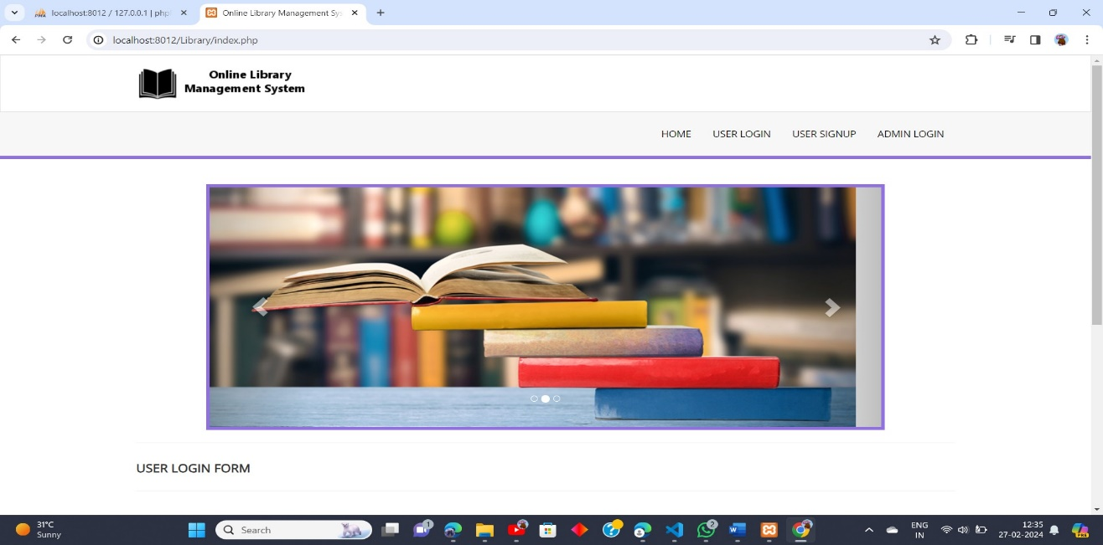

**Figure 1.10 Home page**

**6.2 USER LOGIN PAGE**

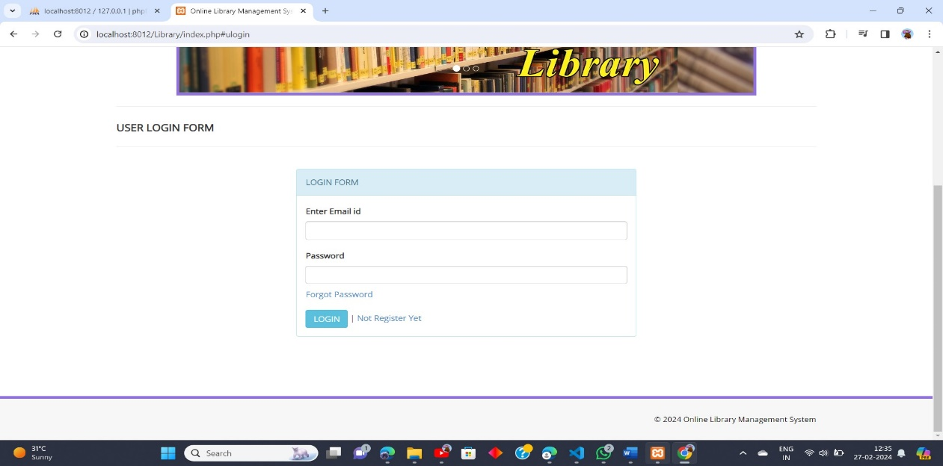

**Figure 1.11 User login page**

**6.3 USER SIGNUP PAGE**

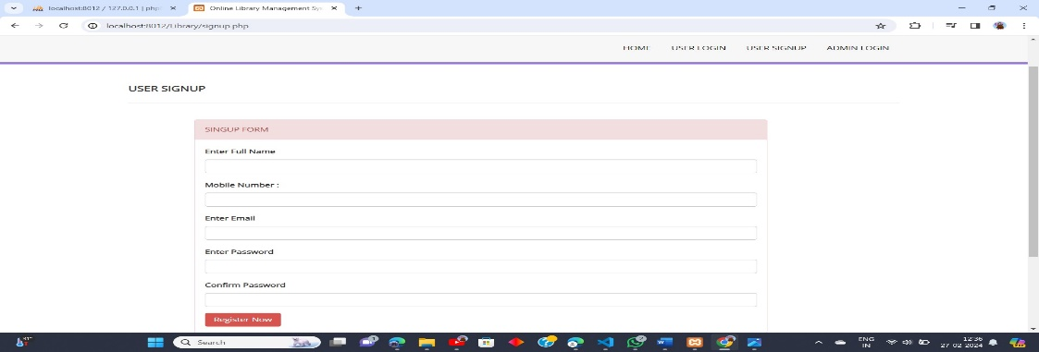

**Figure 1.12 User signup page**

**6.4 ADMIN LOGIN PAGE**

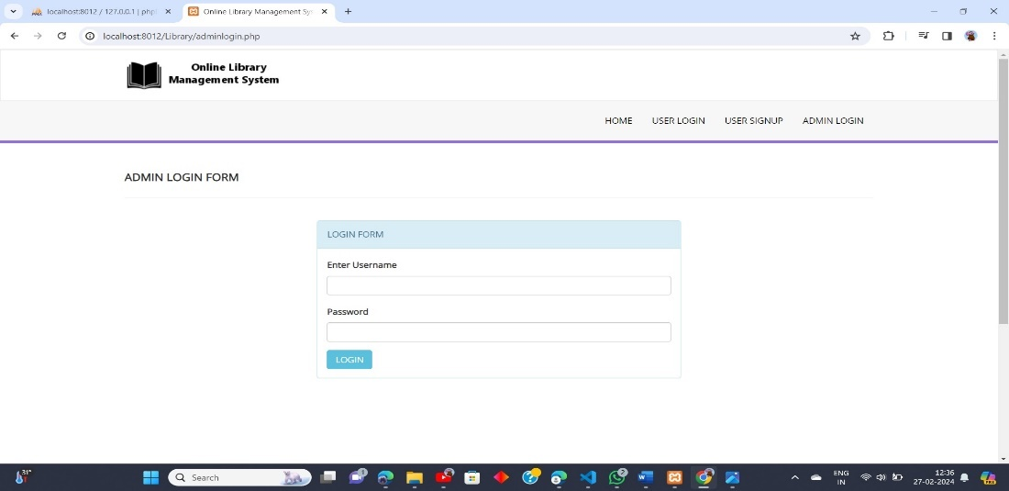

**Figure 1.13 Admin Login page**

**6.5 USER DASHBOARD PAGE**

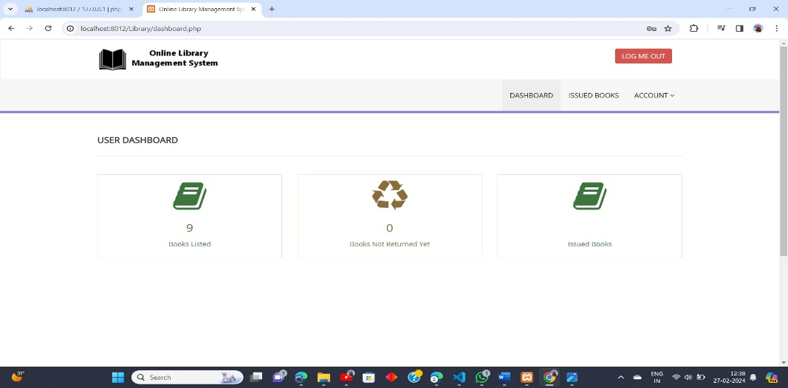

**Figure 1.14 User Dashboard page**

**6.6 ISSUED BOOK PAGE**

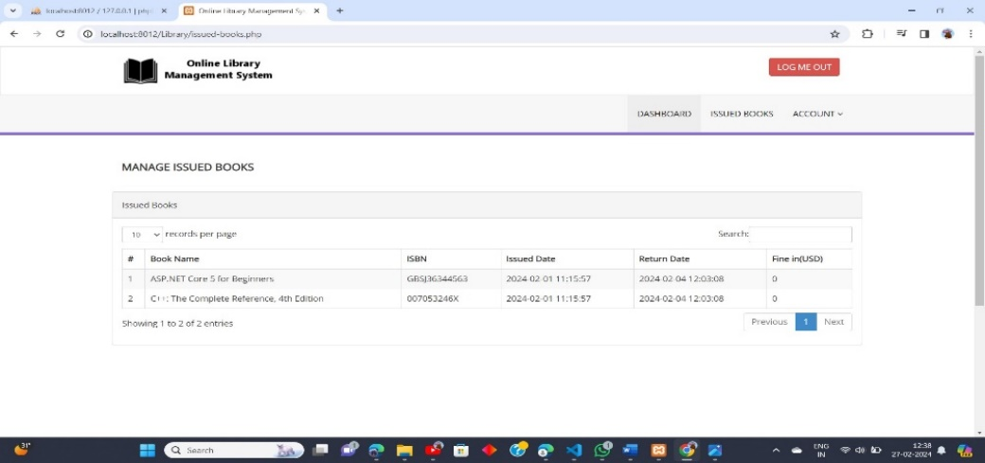

**Figure 1.15 Issued Books page**

**6.7 USER CHANGE PASSWORD PAGE**

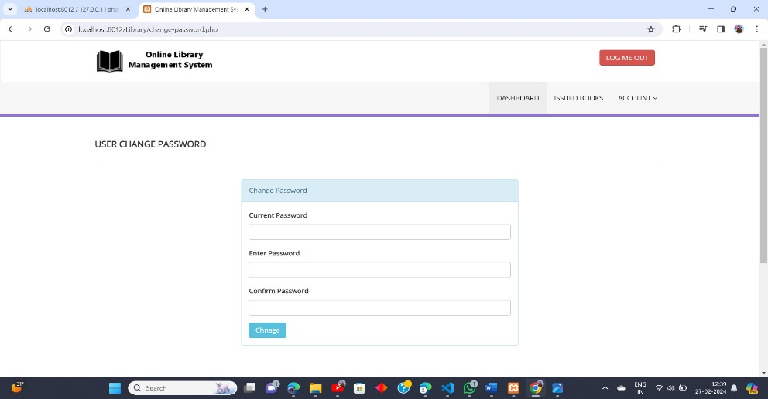

**Figure 1.16 User Change password page**

**6.8 MY PROFILE PAGE**

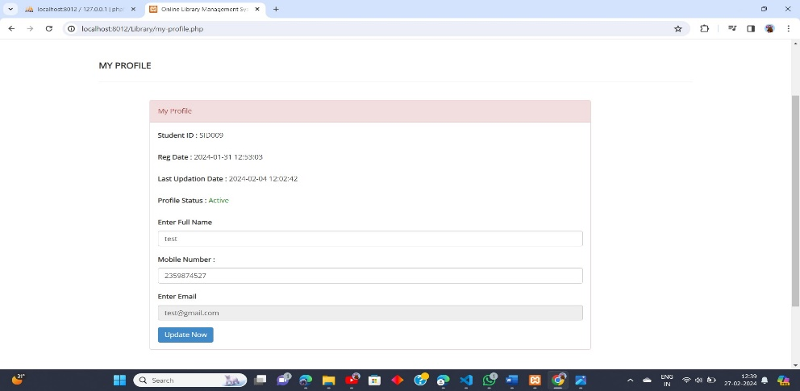

**Figure 1.17 My Profile page**

**6.9 ADMIN DASHBOARD PAGE**

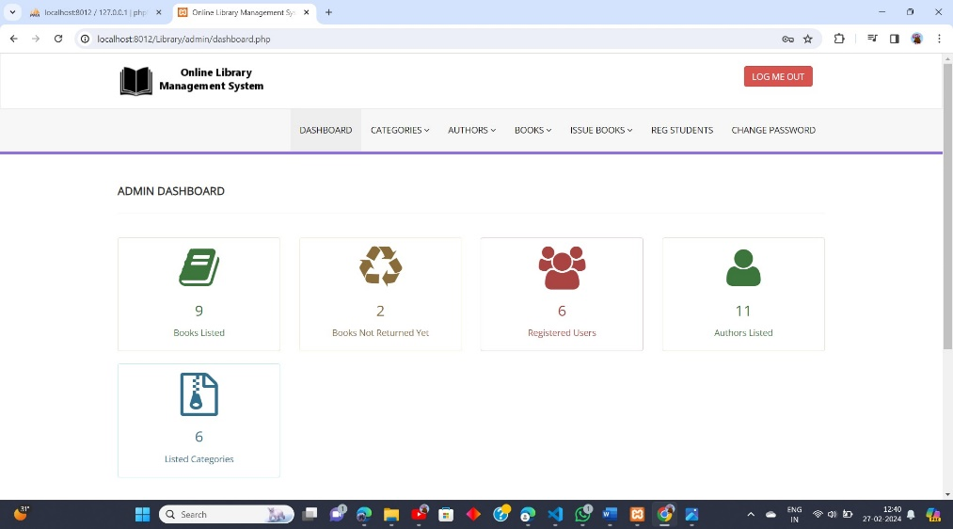

**Figure 1.18 Admin Dashboard page**

**6.10 ADD CATEGORY PAGE**

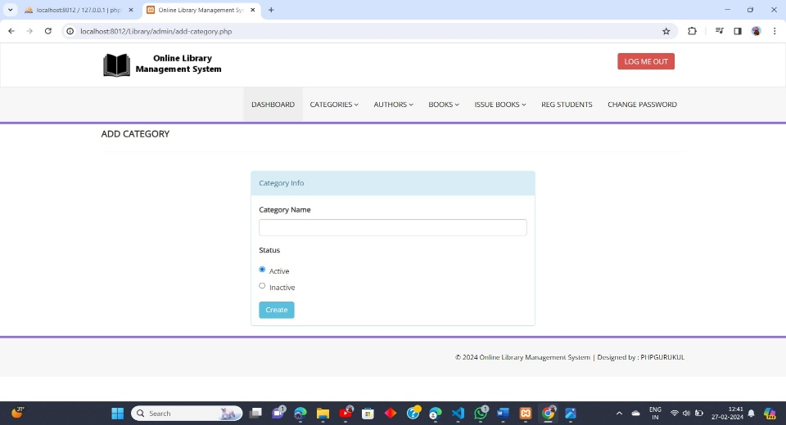

**Figure 1.19 Add category page**

**6.11 MANAGE CATEGORIES PAGE**

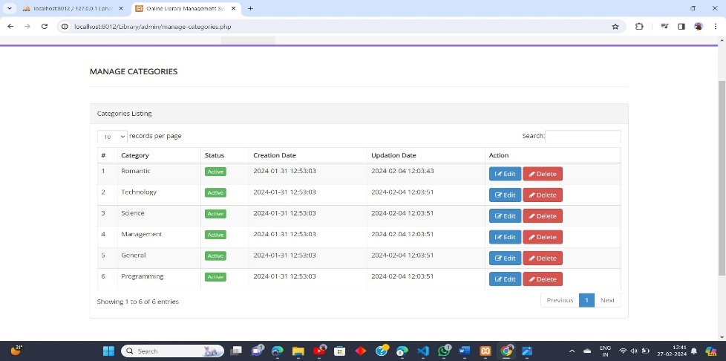

**Figure 1.20 Manage category page**

**6.12 ADD AUTHOR PAGE**

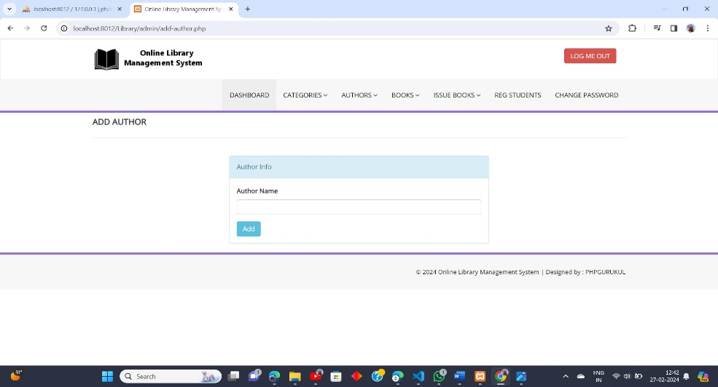

**Figure 1.21 Add Author page**

**6.13 MANAGE AUTHOR PAGE**

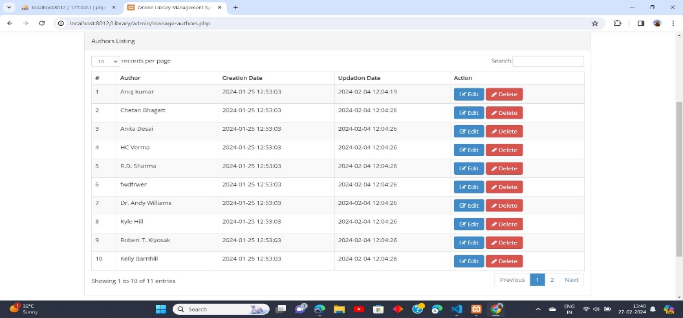

**Figure 1.22 Manage Author page**

**6.14 ADD BOOK PAGE**

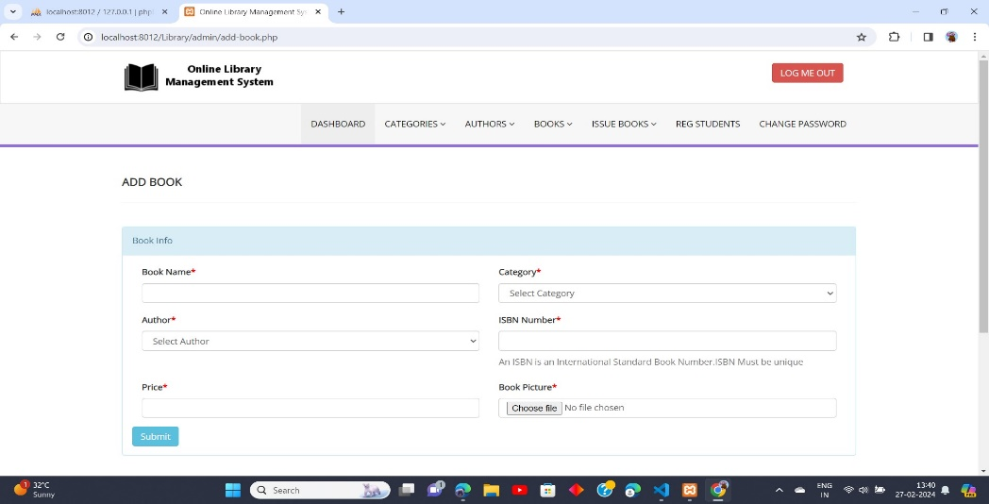

**Figure 1.23 Add Book page**

**6.15 MANAGE BOOK PAGE**

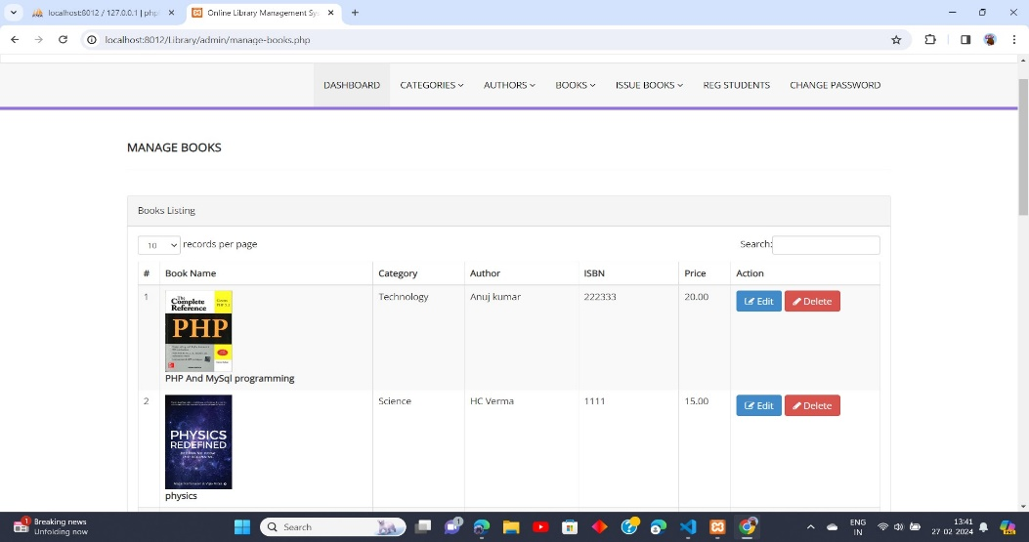

**Figure 1.24 Manage Book page**

**6.16 ISSUE A NEW BOOK PAGE**

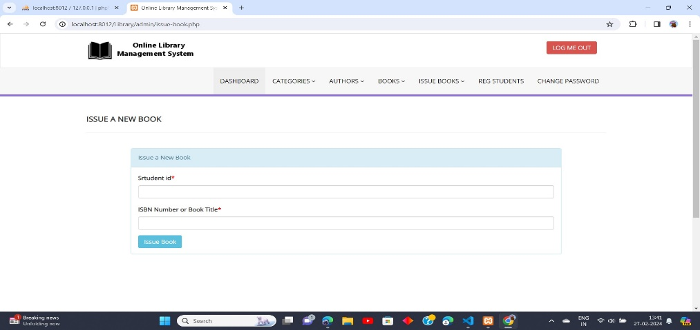

**Figure 1.25 Issue a new Book page**

**6.17 MANAGE ISSUED BOOKS PAGE**

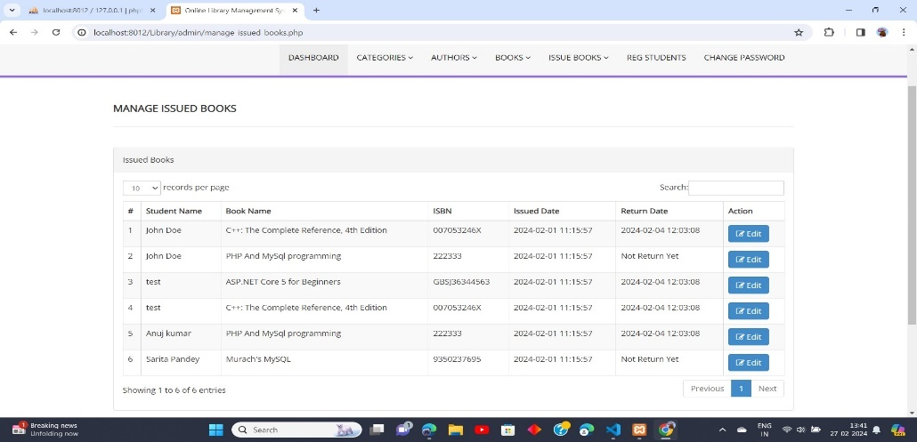

**Figure 1.26 Manage Issued Book page**

**6.18 MANAGE REG STUDENTS PAGE**

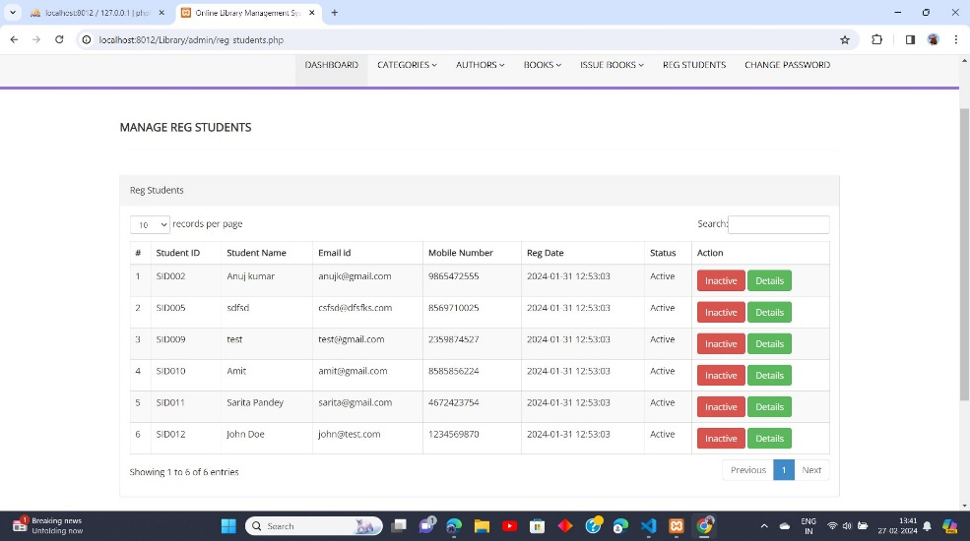

**Figure 1.27 Manage reg student page**

**REFERENCES**

* [**https://www.w3schools.com/php/**](https://www.w3schools.com/php/)
* [**https://w3schools.com/MySQL/**](https://w3schools.com/MySQL/)
* [**https://chat.openai.com/**](https://chat.openai.com/)
* [**https://stackoverflow.com/questions/15930883/connecting-to-mysql-using-apache-and-php**](https://stackoverflow.com/questions/15930883/connecting-to-mysql-using-apache-and-php)
* [**https://goo.gl/K8mszB**](https://goo.gl/K8mszB)